**FRIO COUNTY COMMISSIONERS COURT MINUTES FOR**

**Regular Meeting January 30th, 2024**

On the 30th day of January, 2024, at 3:00 p.m., the Commissioners Court of Frio County met in a regular meeting with the following members either absent or present, to-wit: Rochelle Lozano Camacho, Frio County Judge was present; Joe Vela, Commissioner Pct 1 present; Mario Martinez, Commissioner Pct 2 present; Raul Carrizales, Commissioner Pct 3 present; Danny Cano, Commissioner Pct 4 present; Joseph A. Sindon, Legal Counsel for Frio County Commissioners Court present; and Aaron Ibarra, Frio County Clerk present when the following meeting was held, to-wit: The meeting can be seen unedited and to its full extent on our county website, under the County Clerk tab.

I. Invocation and Pledge of Allegiance

II. Adopt Agenda

**MOTION: COMMISSIONER MARTINEZ**

**SECOND: COMMISSIONER CARRIZALES**

**MOTION PASSED (WITH EDITS)**

III. Old Business

**PRESENTATION**

**ACTION AGENDA ITEMS**

1) Hon. Mike Morse, Frio County Sheriff, requests:

Consider/take action on granting a 6-month extension on the use of FCSO employee vacation hours over 40 accrued hours.

**MOTION: COMMISSIONER CANO**

**SECOND: COMMISSIONER VELA**

**ITEM FAILED**

**COMMISSIONER MARTINEZ**

**COMMISSIONER CARRIZALES**

**JUDGE CAMACHO**

(2) Hon. Rochelle Camacho, Frio County Judge requests:

Consider/take action on granting a 6-month extension on the use of Frio County employee vacation hours over 40 accrued hours.

**MOTION: COMMISSIONER CANO**

**SECOND: COMMISSIONER VELA**

**ITEM FAILED**

**COMMISSIONER MARTINEZ**

**COMMISSIONER CARRIZALES**

**JUDGE CAMACHO**

IV. General Discussion

**2410 & 3314 (CANO) UPDATE FROM JUDGE ALLISON TO REBID**

V. Citizens To Be Heard

**NONE**

VI. New Business

**PRESENTATION**

(1) Ronald Rocha, Attorney at Law, Linebarger Goggan Blair & Sampson, LLP**,** requests:

Update on the delinquent fines and collection services by Linebarger Goggan Blair & Sampson LLP.

(2) Francie Gasch, CASA of South Texas, requests:

Presentation of funding to CASA of South Texas by Frio County.

(3) Robert Cardenas, Membership Sales Manager, AirMedCare, requests:

Presentation regarding current county-wide membership, as well as upgrades for full nation-wide membership.

(4) Dick Murray, requests:

Presentation regarding proposed Game Room Regulations.

**ACTION AGENDA ITEMS**

(1) Mona Hoyle, Frio County Pioneer Jail Museum Association, requests:

Consider/take action to waive the fee for Fireman’s Park rental for the Frio County Pioneer Day on March 23, 2024.

**MOTION: COMMISSIONER CARRIZALES**

**SECOND: COMMISSIONER CANO**

**MOTION: PASSES**

(2) Christopher Ramirez, Frio County Veteran’s Service Officer, requests:

Consider/take action on waiving Fireman’s Park fee for Christopher Ramirez, Frio County Veteran’s Service Officer for an event on March 9, 2024.  It will be a Veterans Health & Wellness Event, car show, food vendors, health care for veterans.

**MOTION: COMMISSIONER CARRIZALES**

**SECOND: COMMISSIONER MARTINEZ**

**MOTION: PASSES**

(3) Sylvia Santos, Frio County Elections Administrator, requests:

3.1 Consider/take action on passing and adopting a resolution authorizing the execution of a Joint Election Agreement and Election Ballot Service Contract between Frio County and the Pearsall Independent School District for the election on May 4, 2024, and with early voting occurring April 22, 2024 to April 30, 2024.

3.2 If resolution is passed and adopted, then authorize the Frio County Judge to execute the Joint Election Agreement and Ballot Service Agreement between Frio County and the Pearsall Independent School District.

3.3 Consider passing and adopting a resolution authorizing the execution of a Lease Agreement for the use of the Frio County’s Electronic Voting Equipment with the Pearsall Independent School District for the election on May 4, 2024, and with early voting occurring April 22, 2024 to April 30, 2024.

3.4 If resolution is passed and adopted, then authorize the Frio County Judge to execute the lease for the use of the Electronic Voting Equipment with the Pearsall Independent School District.

**MOTION: COMMISSIONER CARRIZALES**

**SECOND: COMMISSIONER CANO**

**MOTION: PASSES**

(4) Hon. Mike Morse, Frio County Sheriff, requests:

Consider and Approve payment to Gillette Air Conditioning Company Invoice #W69207 in the amount of $20,000.00 for repair of Frio County Jail Smoke evacuation system.

**MOTION: COMMISSIONER CARRIZALES**

**SECOND: COMMISSIONER MARTINEZ**

**MOTION: PASSES**

(5) Hon. Mike Morse, Frio County Sheriff, requests:

Consider and Approve acceptance of a donation to the Frio County Sheriff’s Office from Atom Construction in the amount of $2,000.00 to be placed in the donations line item.

**MOTION: COMMISSIONER CARRIZALES**

**SECOND: COMMISSIONER MARTINEZ**

**MOTION: PASSES**

**BREAK @ 4:08**

**MOTION: COMMISSIONER CARRIZALES**

**SECOND: COMMISSIONER MARTINEZ**

**MOTION: PASSES**

(6) Hon. Aaron Ibarra, Frio County Clerk, requests:

6.1 Review Frio County Commissioners Court minutes for January 9 and 19, 2024.

**MOTION: COMMISSIONER MARTINEZ**

**SECOND: COMMISSIONER VELA**

**MOTION: PASSES**

6.2 Consider/Approve Frio County Commissioners Court minutes for January 9 and 19, 2024

**MOTION: COMMISSIONER MARTINEZ**

**SECOND: COMMISSIONER CANO**

**MOTION: PASSES**

(7) Ancelmo Ornelas, Frio County Road and Bridge Administrator, requests:

Discuss/approve quote #81639 from T & W Tire for $5,271.58 for purchase of 4- 17.5R25 Hercules tires for motor grader and miscellaneous items (tire disposal, fuel surcharge, dismount/install).

**MULTIPLE QUOTES REQUESTED (ITEAM TABLED)**

(8) Ancelmo Ornelas, Frio County Road and Bridge Administrator, requests:

Discuss/approve quote from Holt Cat for $5,308.00 for quantity of 100 edge (blades) for motor graders.

(OMIT)

(9) Ancelmo Ornelas, Frio County Road and Bridge Administrator, requests:

9.1 Consider/take action on approving and a permit to Select Water Solutions, LLC to lay, construct and maintain 12” lay flat line in the right-of-way of CR 3871This is to connect a new customer on the east side of CR 3420 at Block 6, Lots 10 & 11.   Total permit fee $150.00

9.2 If the permit is approved, consider/take action on approving and adopting a resolution to authorize Frio County Judge Hon. Rochelle Camacho to sign same on behalf of Frio County.

**MOTION: COMMISSIONER CARRIZALES**

**SECOND: COMMISSIONER CANO**

**MOTION: PASSES**

(10) Ancelmo Ornelas, Frio County Road and Bridge Administrator, requests:

10.1 Consider/take action on approving and adopting resolutions granting permits to Trinity Operating (USG), LLC to temporarily lay, construct and maintain by cutting one (1) 6” water pipeline under the County Roads 4700 right-of-way for a total permit fee of $500.00.

10.2 If the resolution is approved and adopted, then authorize Frio County Judge Arnulfo C. Luna to execute the permit on behalf of Frio County, Texas to Barbara S. Ruel.

**MOTION: COMMISSIONER CANO**

**SECOND: COMMISSIONER CARRIZALES**

**MOTION: PASSES**

(11) Tommy Navarro, Frio County Building Maintenance Supervisor, requests:

Discuss/take action on approving the minimizing/eliminating some handicap and senior citizen parking slots on the West Side parking lot of the Frio County Court House.

**MOTION: COMMISSIONER MARTINEZ**

**SECOND: COMMISSIONER CANO**

**MOTION: PASSES**

(12) Hon. Mario Martinez, Frio County Commissioner, Precinct No. 2, requests:

Consider / take action on approving additional streetlights at the following locations in Moore, Texas:

1) 4th Street near the Interstate 35 Frontage Road;

2) 2nd Street near the Interstate 35 Frontage Road;

3) County Road 2690 near the Interstate 35 Frontage Road;

4) County Road 2627 near the Interstate 35 Frontage Road;

5) County Road 1543 near the Interstate 35 Frontage Road;

6) County Road 1615 near the intersection of FM 462;

7) County Road 1660 near the intersection of FM 462;

**MOTION: COMMISSIONER MARTINEZ**

**SECOND: COMMISSIONER CANO**

**MOTION: PASSES**

(13) Hon. Crystal Marquez, Frio County Auditor, requests:

Consider / take action on the acceptance of donated funds totaling the amount of $500.00 from Linebarger Goggan Blair & Sampson, LLP to the Frio County Employee Christmas Party.

**MOTION: COMMISSIONER MARTINEZ**

**SECOND: COMMISSIONER CANO**

**MOTION: PASSES**

(14) Hon. Crystal Marquez, Frio County Auditor, requests:

14.1 Consider / take action to approve the budget amendments to the FISCAL YEAR 2023-2024 Frio County Budget, list below:

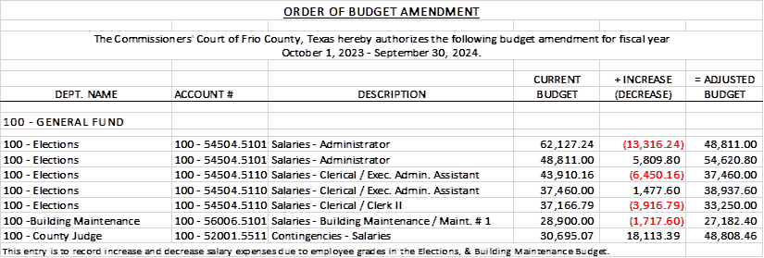

14.2 If the amendment is approved, consider/take action on signing order stating same.

**MOTION: COMMISSIONER CARRIZALES**

**SECOND: COMMISSIONER CANO**

**MOTION: PASSES**

(15) Hon. Crystal Marquez, Frio County Auditor, requests:

15.1 Consider / take action to approve the budget amendments to the FISCAL YEAR 2023-2024 Frio County Budget, list below:

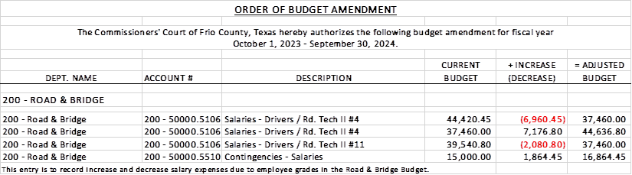

15.2 If the amendment is approved, consider/take action on signing order stating same.

**MOTION: COMMISSIONER CARRIZALES**

**SECOND: COMMISSIONER MARTINEZ**

**MOTION: PASSES**

(16) Hon. Crystal Marquez, Frio County Auditor, requests:

16.1 Consider / take action to approve the budget amendments to the FISCAL YEAR 2023-2024 Frio County Budget, list below:

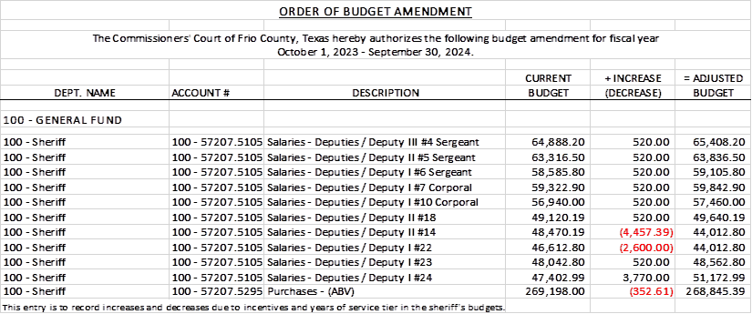

16.2 If the amendment is approved, consider/take action on signing order stating same.

**MOTION: COMMISSIONER CANO**

**SECOND: COMMISSIONER CARRIZALES**

**MOTION: PASSES**

(17) Documents (resolutions, orders, contracts, etc.) to be signed.

**MOTION: COMMISSIONER CARRIZALES**

**SECOND: COMMISSIONER CANO**

**MOTION: PASSES**

(18) Allow bills payable

**MOTION: COMMISSIONER CARRIZALES**

**SECOND: COMMISSIONER CANO**

**MOTION: PASSES**

(19) Adjourn

**MOTION: COMMISSIONER CARRIZALES**

**SECOND: COMMISSIONER MARTINEZ**

**MOTION: PASSES**